**Setting up Application Environment**

**Create Flask Project**

|  |  |
| --- | --- |
| Date | 01 November 2022 |
| Batch ID | PNT2022TMID31466 |
| Project Name | Skills/Job Recommender Application |

# Step 1. Install Python latest version from python.org

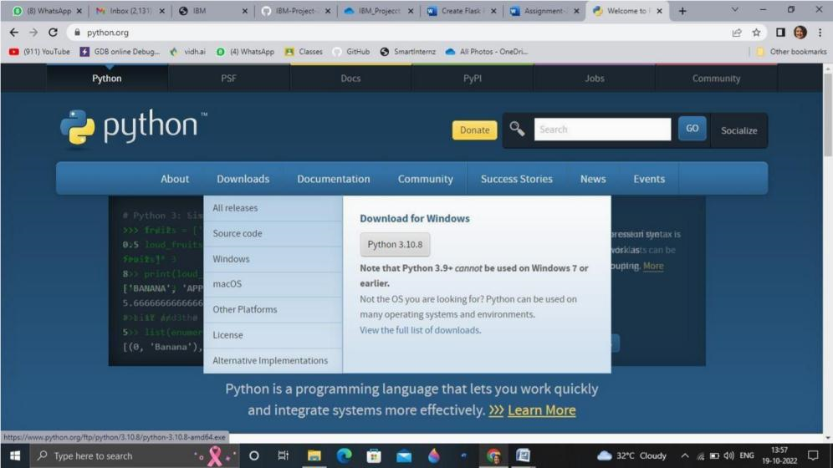

Step 2. Download Anaconda from [https://www.anaconda.com/ an](https://www.anaconda.com/)d install it by running the .exe file

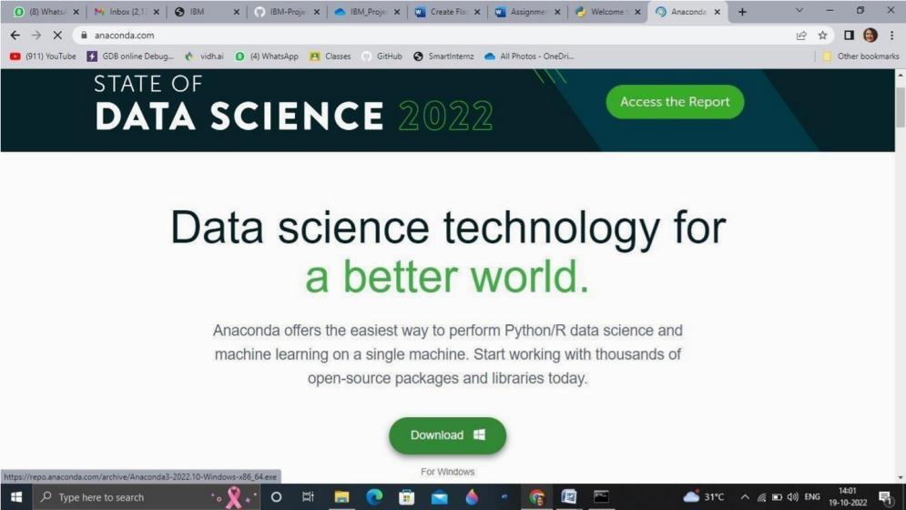

# Step 3.Install Flask using command pip install flask

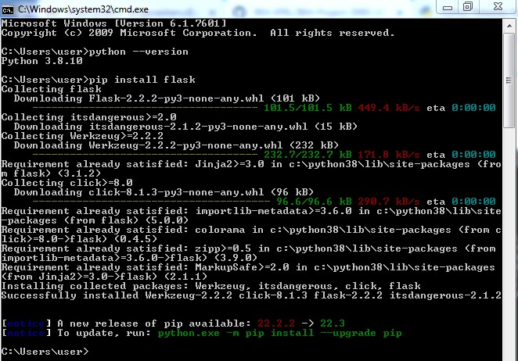

# Step 4.Open a new Python file and start coding

from flask import Flask app = Flask( name ) @app.route('/') def hello(): return “Hello World”

# if name == ' main ': app.run(debug=True) Step 5. Run the Python file using command python filename.py

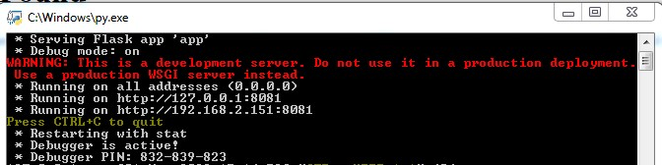

# Step 6: Open the Ip in browser

